**Aim:**

**UML DIAGRAM FOR ONLINE SHOPPING**

To draw UML diagram for Online Shopping using

umbrello tool

**USE CASE DIAGRAM**

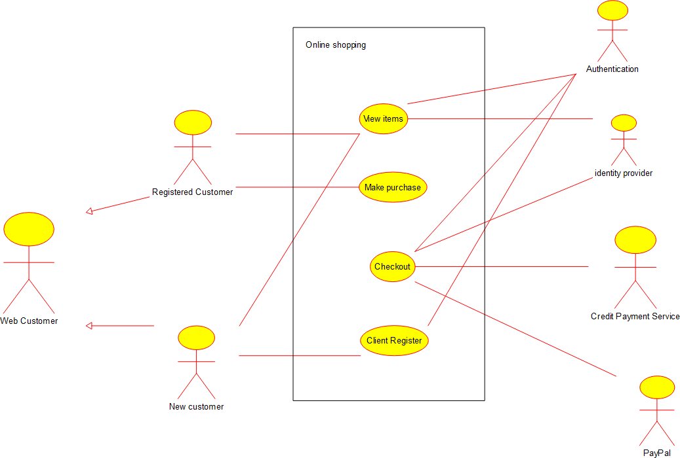

**CLASS DIAGRAM**

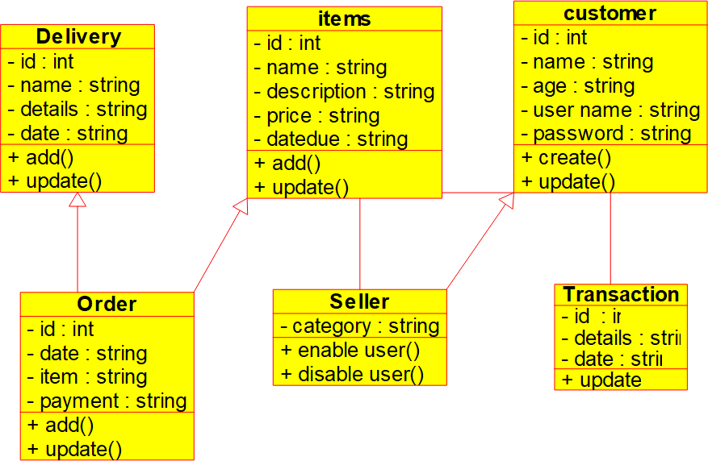

**ACTIVITY DIAGRAM**

